Name: Rushiraj Suwarnkar  
Roll no.: 381018  
PRN: 22310315  
———————————————————————————————

**Assignment 8: Implement Backward Chaining Algorithm**  
———————————————————————————————

**Problem Statement:**  
Implement the Backward Chaining algorithm to infer whether a specific goal can be satisfied using a given knowledge base of facts and rules. The system should work by starting from the goal and checking if it can be derived from known facts.  
———————————————————————————————

**Objectives:**

* Understand the concept of Backward Chaining in inference systems.
* Implement Backward Chaining for goal-driven problem solving.
* Apply Backward Chaining to verify if a goal can be reached from existing knowledge.  
  ———————————————————————————————

**Theory:**  
———————————————————————————————

**Methodology:**  
Backward Chaining is a goal-driven inference technique used in expert systems. It starts with the goal and works backward by looking for rules that can infer the goal. The algorithm recursively checks whether the conditions (antecedents) of these rules can be satisfied by known facts or other rules, continuing until the goal is proven or disproven.  
———————————————————————————————

**Working Principle / Algorithm:**  
———————————————————————————————

**Backward Chaining Algorithm:**

1. Start with the goal to be proven.
2. Search for rules in the knowledge base that can infer the goal.
3. For each rule, check if all its antecedents (conditions) are satisfied:
   * If a condition is a known fact, it is satisfied.
   * If a condition is not known, recursively attempt to prove it as a sub-goal.
4. If all conditions are satisfied, the goal is proven; otherwise, it fails.
5. Repeat until the main goal is verified or no further rules apply.  
   ———————————————————————————————

**Advantages:**

* Efficient for problems with a specific goal.
* Avoids unnecessary inference by focusing only on the goal.
* Suitable for expert systems where target conclusions are important.  
  ———————————————————————————————

**Disadvantages / Limitations:**

* May not find all possible conclusions, only goal-driven paths.
* Can become inefficient if the goal requires deep recursion.
* Requires careful management of rule dependencies to avoid infinite loops.  
  ———————————————————————————————

**Diagram:**

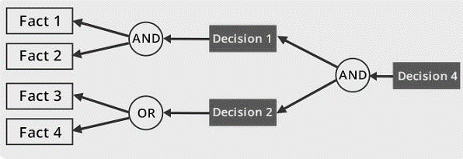  
———————————————————————————————

**Conclusion:**  
Backward Chaining is a fundamental goal-driven reasoning technique in knowledge-based systems. By starting from a goal and working backward through rules, it efficiently determines whether the goal can be satisfied using the existing facts and knowledge base.  
———————————————————————————————